LCC RPiPico Node (v3.0)
An open, DIY-friendly Raspberry Pi Pico platform for OpenLCB / LCC model railroad control
Bob Gamble · bocabobgamble@gmail.com · github.com/bocabob
The LCC RPiPico Node is a single, general-purpose board design that replaces a whole family of earlier dedicated boards. Specialized functions — displays, stepper drivers, servos, and more — plug in as breakout boards rather than requiring a new board revision for every node type. It grew out of LocoNet turntable controllers dating back to 2021 and migrated to full LCC/OpenLCB support in 2024.

WHY IT’S AN EASY DIY ENTRY POINT
- Arduino IDE — programmed with the standard Earle Philhower RP2040 board package; no CMake/toolchain setup.
- Full LCC/OpenLCB stack included via the OpenLcbCLib library — alias allocation, datagrams, CDI, memory config, and more already implemented.
- One board, every node type — swap breakout boards instead of re-designing hardware for each new function.
- Hand-solderable — discrete MCP2518/MCP2562 CAN chips instead of hard-to-hand-solder integrated parts.
- Documented pin/architecture standard shared across every example project, so patterns learned on one node transfer directly to the next.
- Working example firmware to copy — four complete, real-world node applications with full source (see right).

KEY BOARD ATTRIBUTES
- Processor: Raspberry Pi Pico or Pico 2 (Pico 2 recommended)
- CAN: discrete MCP2518 controller + MCP2562 transceiver
- Power: dual 3.3V/5V switching regulation; power from LCC bus or 8–15V external; can inject power onto the bus
- NVM: I2C EEPROM or FRAM (onboard footprint or plug-in module) — spares the Pico’s flash from wear
- I/O: 16 GP pins via two 10-pin IDC connectors (I/O-1, I/O-2) + a 6-pin analog header (I/O-3)
- Breakout ecosystem: touchscreen displays (SPI or parallel), stepper driver, servo, and test/ribbon breakouts
- Buttons: onboard reset (Pico has none) + header for a remote reset button; Blue/Gold user buttons where pins allow
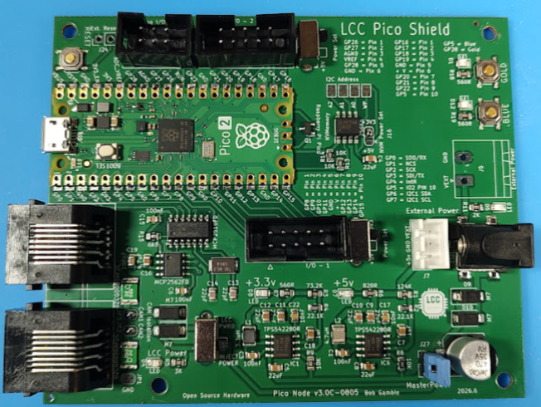
EXAMPLE NODE PROJECTS (OPEN SOURCE, FULL FIRMWARE ON GITHUB)

- Turntable — Motorized turntable controller — stepper-driven positioning, home/limit sensing, touchscreen UI with track selection, bridge animation, and RailCom occupancy display.
- Roundhouse — Multi-stall roundhouse door control — servo-driven doors synchronized to turntable track selection.
- PixelLights — Addressable NeoPixel lighting controller — scene/effect control for structure, signal, or ambient layout lighting over LCC events.
- Clock Lights — Layout lighting tied to the LCC fast clock — day/night lighting transitions and dimming driven by the shared broadcast fast-clock protocol.

GET STARTED
- Board hardware (schematics, PCB, gerbers, breakout designs): github.com/bocabob/LCC-RPi-Pico-Board
- Firmware architecture standard & example applications: github.com/bocabob/LCC_RPiPico_Common
- Board support: Earle Philhower’s RP2040 core (arduino-pico) — install via the Arduino IDE Boards Manager
- LCC protocol stack: OpenLcbCLib (Jim Kueneman) / OpenLCB Single Thread — linked from the Common repo above

